OLI Course Setup for Instructors

On the first launch of a new course, Instructors/Administrators must set up their OLI course by following a few simple steps to configure the content they wish to deliver to students.

- Click Yes, let’s get started

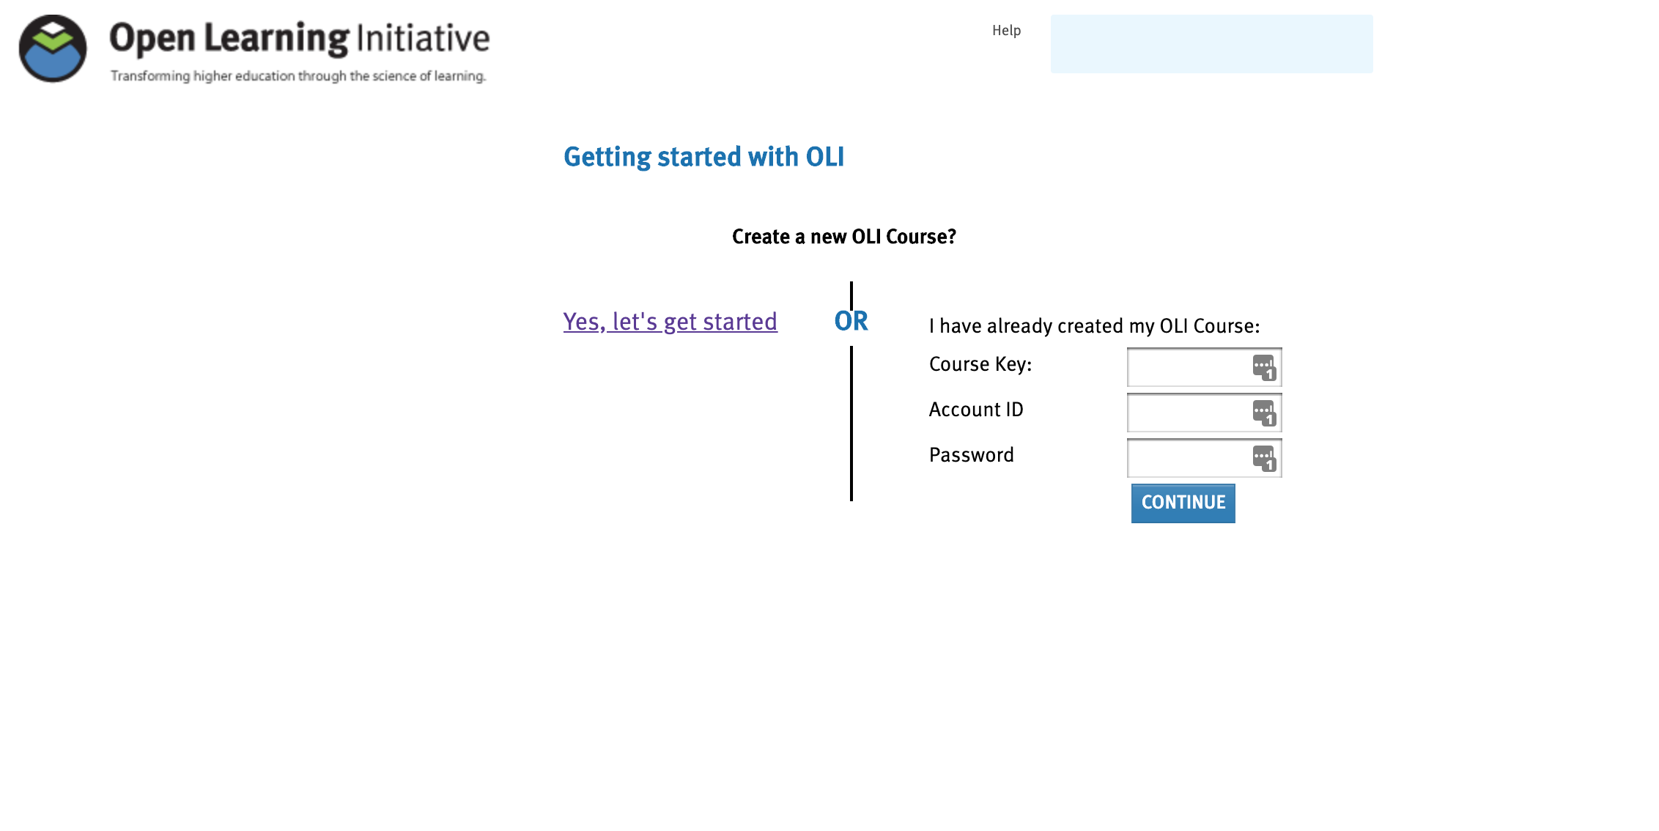

- Select Simple Mode and click Next
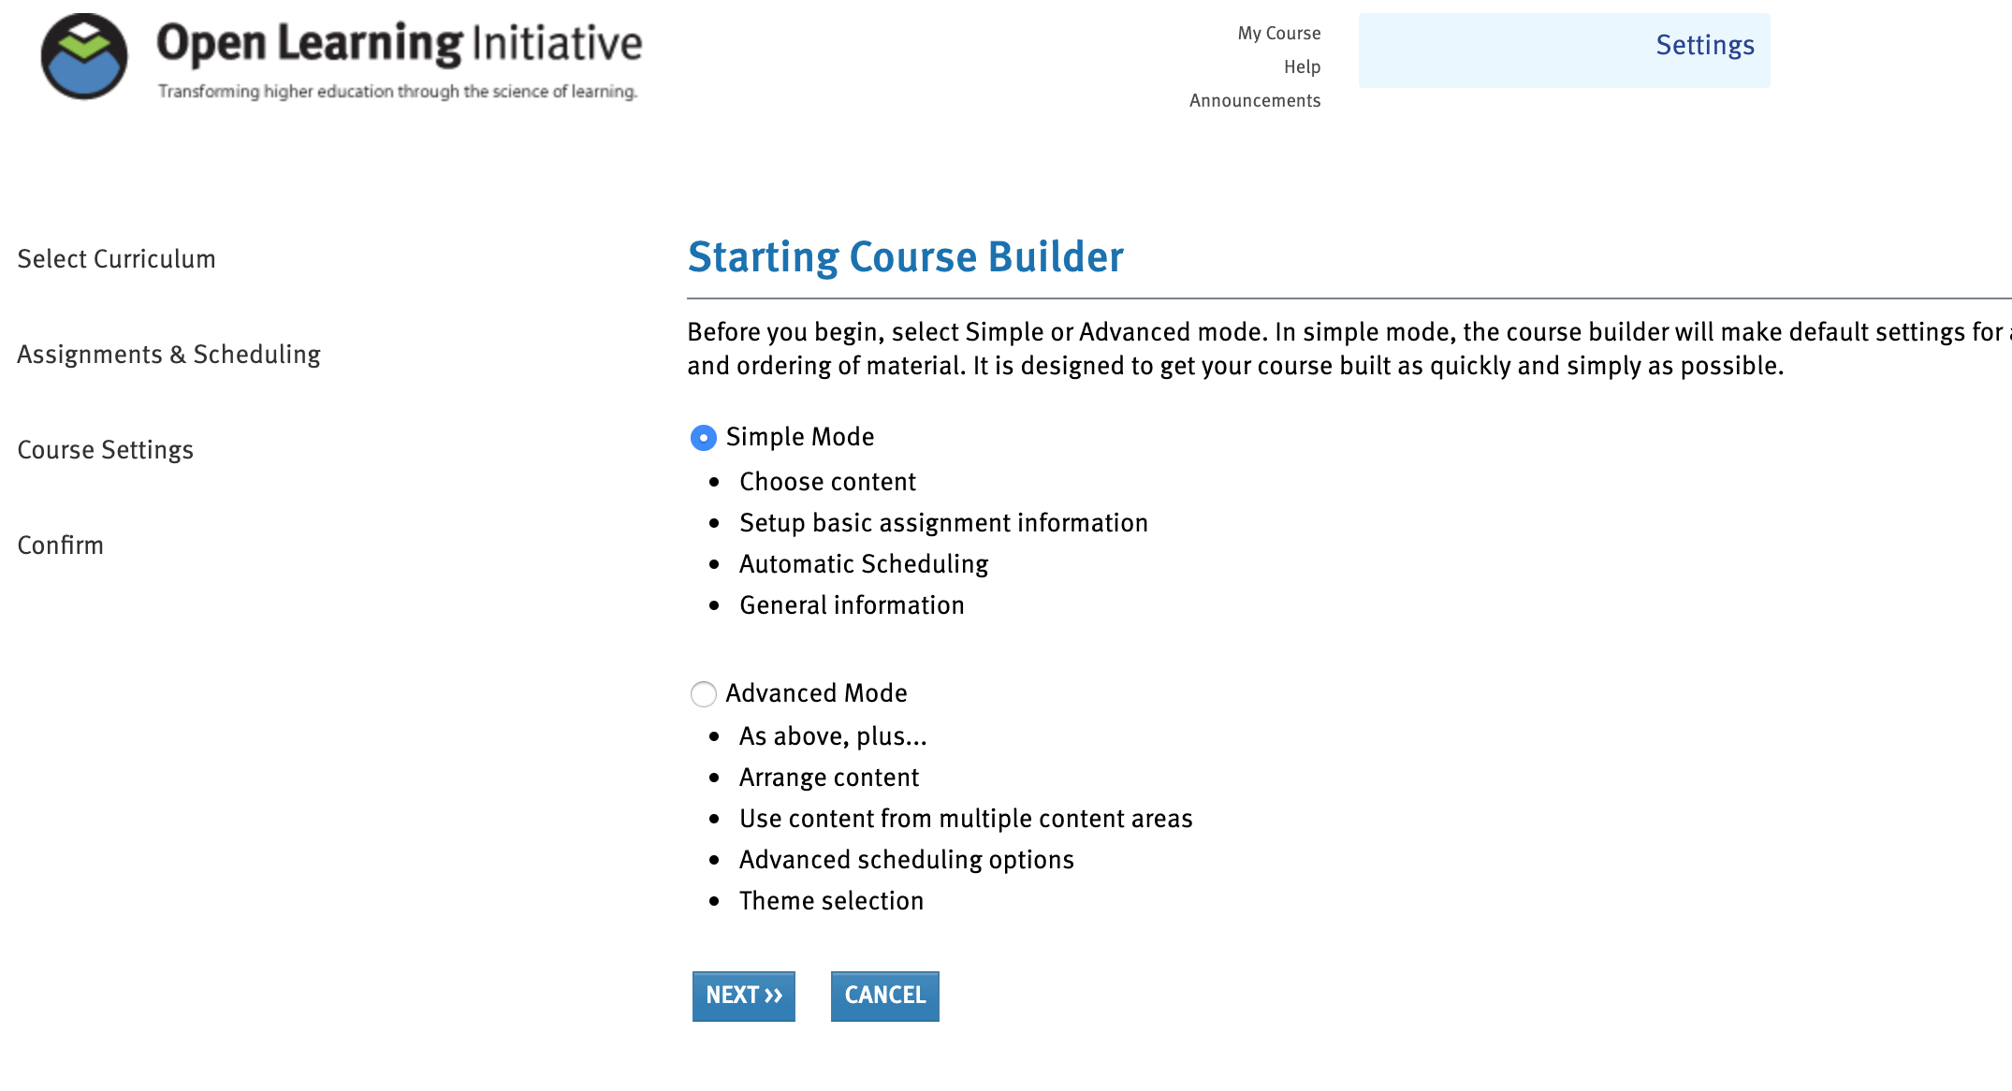

- Select the course you intend to offer as the curriculum, then click Next

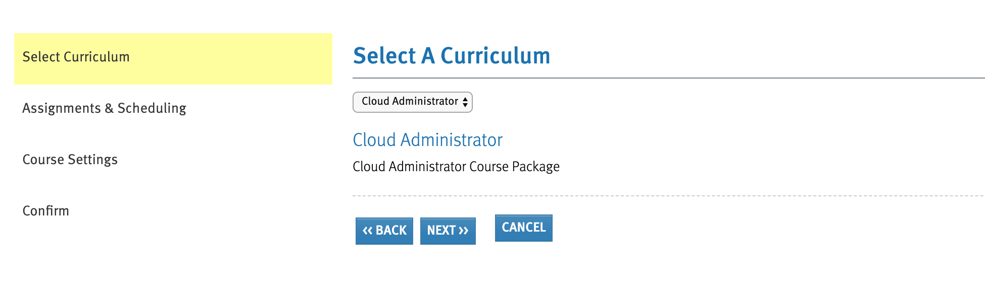

- Select an End Date (click the calendar link for easy selection. Note: This date is simply for scheduling purposes and does not affect the availability or grading of the course content.) Click Next
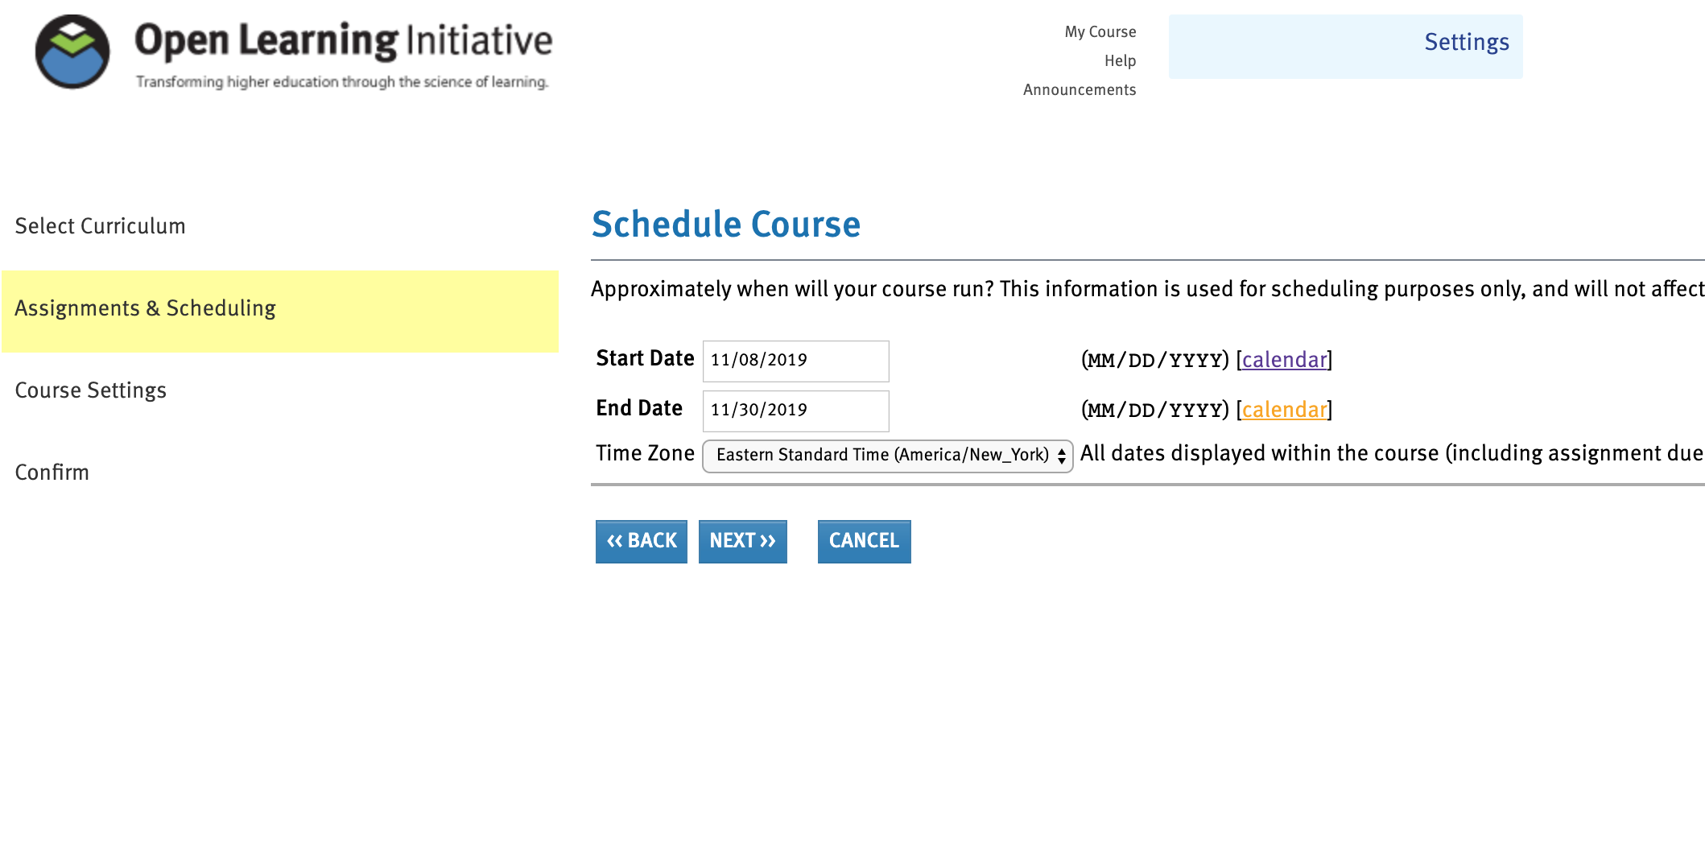

- Verify the Title and Institution Name are correct, update if necessary. These will default to information sent from your LMS.
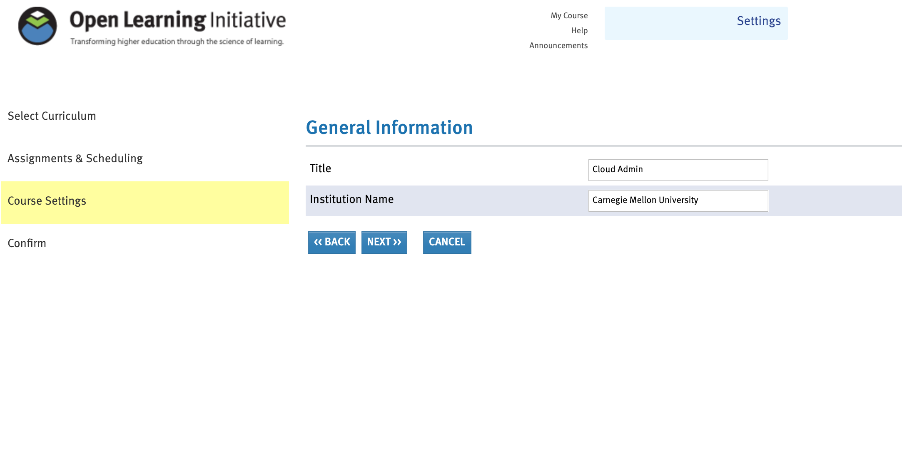

- Verify all the information shown is correct, then click Next
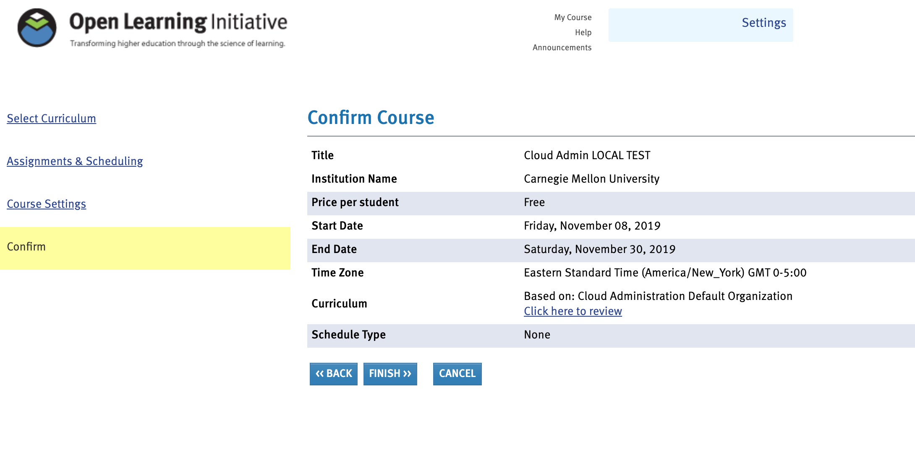

All done! Your OLI course content is now ready for students to access through the Sail() portal.

